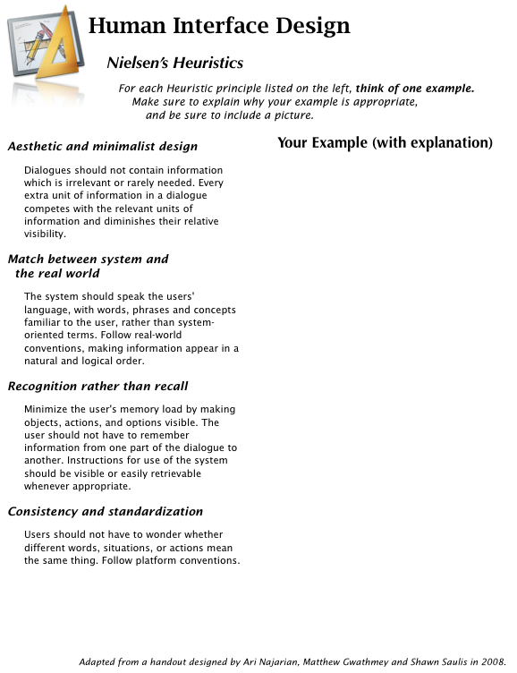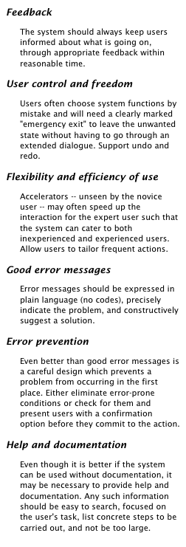

Type your names

in this box

Type here

Type here

Type here

Type here

Type here

Type here

Type here

Type here

Type here

Type here