Introducing the Computer :: Digital Handout

*Please answer the following questions, and complete the activities on the next three pages. Save your file and submit it to Mr. Najarian.*

1. What is a computer?

2. What is the definition of hardware?

3. What is software?

4. Can a computer function without any storage hardware components? Why or why not?

5. Is the Internet considered software? Why or why not?

6. Is an operating system considered software? Why or why not?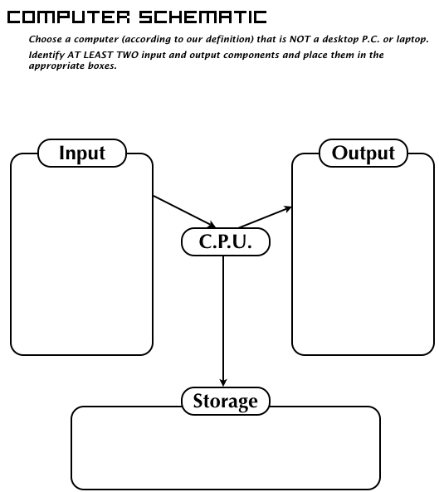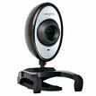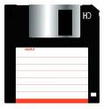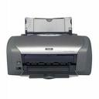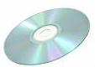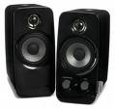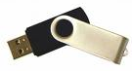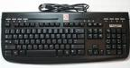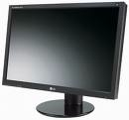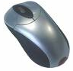 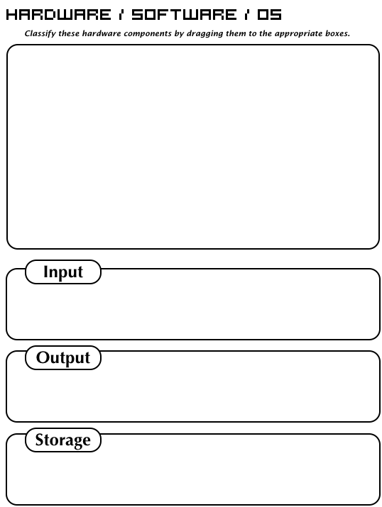

**Type Here**

**Type Here**

**Type Here**

**The computer I chose is:**

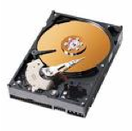

Hard Drive

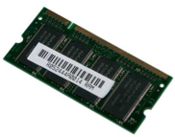

RAM

Display

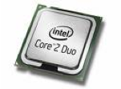

CPU

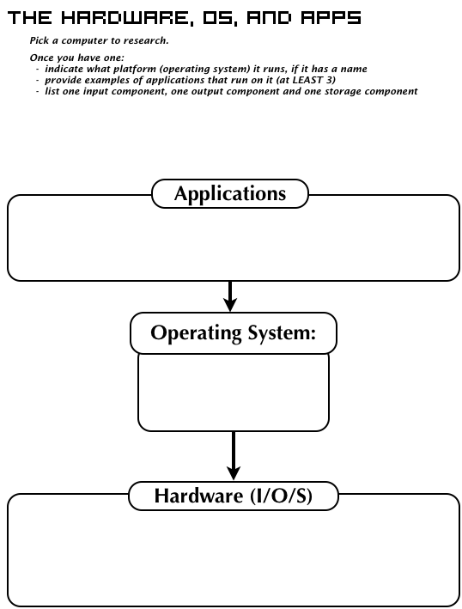

**Type Here**

**The computer I chose is:**

**Type Here**

**Type Here**